WEEK 4
AIM:To determine whether a given integer array contains any duplicate elements.
If any value appears more than once, return true; otherwise, return false.
ALGORITHM :
Start
Create an empty HashSet to store integers.
Traverse each element in the given array nums.
For each element:
If the element is already present in the HashSet,
return true (duplicate found).
Otherwise, add the element to the HashSet.
If the traversal completes without finding duplicates,
return false.
Stop
Program:
import java.util.*;
public class Solution {
static int[] compareTriplets(int[] a, int[] b) {
int aliceScore = 0;
int bobScore = 0;
for (int i = 0; i < 3; i++) {
if (a[i] > b[i]) {
aliceScore++;
} else if (a[i] < b[i]) {
bobScore++;
}
}
return new int[] { aliceScore, bobScore };
}
public static void main(String[] args) {
Scanner sc = new Scanner(System.in);
int[] a = new int[3];
int[] b = new int[3];
for (int i = 0; i < 3; i++) {
a[i] = sc.nextInt();
}
for (int i = 0; i < 3; i++) {
b[i] = sc.nextInt();
}
int[] result = compareTriplets(a, b);
System.out.println(result[0] + " " + result[1]);
}
}
Output:
5 6 7
3 6 10
1 1

Result:Thus the implementation of the triplets was executed successfully and executed successfully and output was verified.
Aim:
To determine whether a given integer array contains any duplicate elements.
If any value appears more than once, return true; otherwise, return false.
Algorithm :
Start
Create an empty HashSet to store integers.
Traverse each element in the given array nums.
For each element:
If the element is already present in the HashSet,
return true (duplicate found).
Otherwise, add the element to the HashSet.
If the traversal completes without finding duplicates,
return false.
Stop
Program:
import java.util.HashSet;
class Solution {
public boolean containsDuplicate(int[] nums) {
HashSet<Integer> set = new HashSet<>();
for (int num : nums) {
if (set.contains(num)) {
return true; }
set.add(num);
}
return false;
}
}

Output:

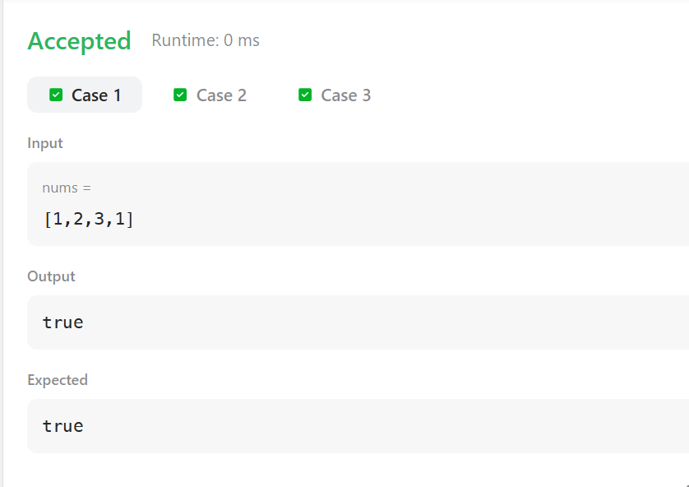

Result:
Thus the implementation of the duplicates was executed successfully and output has been verified successfully .

Aim
To compute the transpose of a given matrix by converting rows into columns.
Algorithm
Find the number of rows m and columns n in the matrix.
Create a new matrix transpose of size n × m.
Traverse the original matrix:
Assign transpose[j][i] = matrix[i][j].
Return the transposed matrix.
Program:
class Solution {
public int[][] transpose(int[][] matrix) {
int m = matrix.length;
int n = matrix[0].length;
int[][] result = new int[n][m];
for (int i = 0; i < m; i++) {
for (int j = 0; j < n; j++) {
result[j][i] = matrix[i][j];
}
}
return result;
}
}

Output:

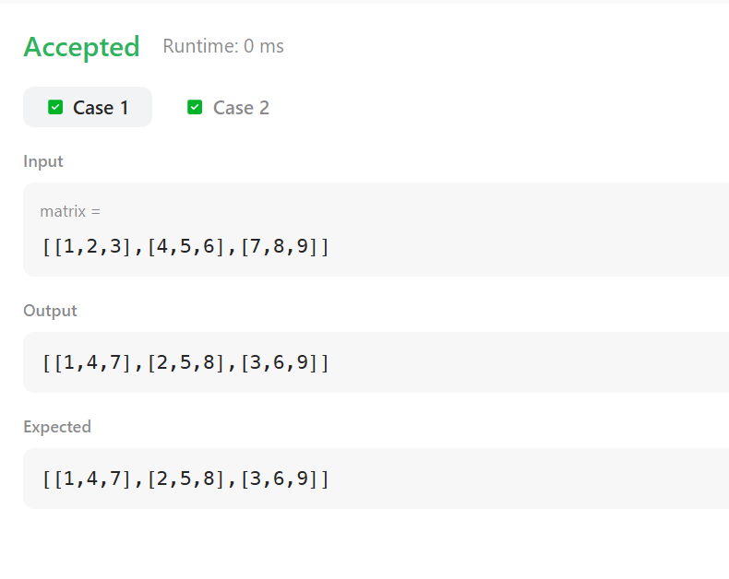

Result:
Thus the implementation of the matrix transpose was executed successfully and output was verified.

Aim:
To move all zeroes in the given array to the end while maintaining the relative order of non-zero elements.
ALGORITHM:
Initialize an index k = 0.
Traverse the array:
If the element is non-zero, place it at index k and increment k.
After traversal, fill the remaining positions with 0.
Print the modified array.
Program:
class Solution {
public void moveZeroes(int[] nums) {
int k = 0;
for (int i = 0; i < nums.length; i++) {
if (nums[i] != 0) {
nums[k++] = nums[i];
}
}
while (k < nums.length) {
nums[k++] = 0;
}
}
}

Output:

Result:
Thus the implementation of the move zeroes in the leet code was executed successfully and output has been verified successfully.

AIM:
To convert time from 12-hour AM/PM format to 24-hour military format.

ALGORITHM:
Extract hours, minutes, seconds, and AM/PM.
If time is AM:
Convert 12 AM to 00.
If time is PM:
Add 12 to hours if not 12 PM.
Return the converted time.

Program:
class Result {
public static String timeConversion(String s) {
String period = s.substring(8);
int hour = Integer.parseInt(s.substring(0, 2));
String rest = s.substring(2, 8);

if (period.equals("AM")) {
if (hour == 12) hour = 0;
} else {
if (hour != 12) hour += 12;
}

return String.format("%02d", hour) + rest;
}
}

Output:
07:05:45PM
19:05:45

Result:
Thus the implementation of the time conversion in hacker rank was executed successfully and output was verified.

AIM:
To calculate the absolute difference between the sums of the matrix’s primary and secondary diagonals.
ALGORITHM:
Initialize primarySum = 0 and secondarySum = 0.
Traverse the matrix:
Add matrix[i][i] to primary diagonal sum.
Add matrix[i][n - i - 1] to secondary diagonal sum.
Return absolute difference.

Program:
class Result {
public static int diagonalDifference(List<List<Integer>> arr) {
int n = arr.size();
int primary = 0, secondary = 0;

for (int i = 0; i < n; i++) {
primary += arr.get(i).get(i);
secondary += arr.get(i).get(n - i - 1);
}

return Math.abs(primary - secondary);
}
}

Output:
3
11 2 4
4 5 6
10 8 -12

Result:
Thus the implementation of the diagonal difference in hacker rank was executed successfully and output has been verified.

Aim:To compute the block sum for each element of a matrix such that every element (i, j) in the result matrix contains the sum of all elements within a distance K from (i, j) using an efficient prefix sum approach.
Algorithm:
Read input matrix mat and integer K.
Create a prefix sum matrix prefix of size (m + 1) × (n + 1) initialized to 0.
Build the prefix sum matrix
For each cell (i, j):
Add the current element.
Add the sum from the top.
Add the sum from the left.
Subtract the overlapping top-left value.
Initialize the result matrix result of size m × n.
For each cell (i, j) in the matrix:
Determine the block boundaries:
r1 = max(0, i − K)
c1 = max(0, j − K)
r2 = min(m − 1, i + K)
c2 = min(n − 1, j + K)
Compute the block sum using the prefix sum formula:
blockSum =
prefix[r2 + 1][c2 + 1]
− prefix[r1][c2 + 1]
− prefix[r2 + 1][c1]
+ prefix[r1][c1]
Store the computed block sum in result[i][j].
Return the result matrix.
Program:
class Solution {
public int[][] matrixBlockSum(int[][] mat, int k) {
int m = mat.length, n = mat[0].length;

int[][] prefix = new int[m + 1][n + 1];
for (int i = 1; i <= m; i++) {
for (int j = 1; j <= n; j++) {
prefix[i][j] = mat[i - 1][j - 1]
+ prefix[i - 1][j]
+ prefix[i][j - 1]
- prefix[i - 1][j - 1];
}
}
int[][] result = new int[m][n];
for (int i = 0; i < m; i++) {
for (int j = 0; j < n; j++) {
int r1 = Math.max(0, i - k);
int c1 = Math.max(0, j - k);
int r2 = Math.min(m - 1, i + k);
int c2 = Math.min(n - 1, j + k);
result[i][j] = prefix[r2 + 1][c2 + 1]
- prefix[r1][c2 + 1]
- prefix[r2 + 1][c1]
+ prefix[r1][c1];
}
}
return result;
}
}
Output:

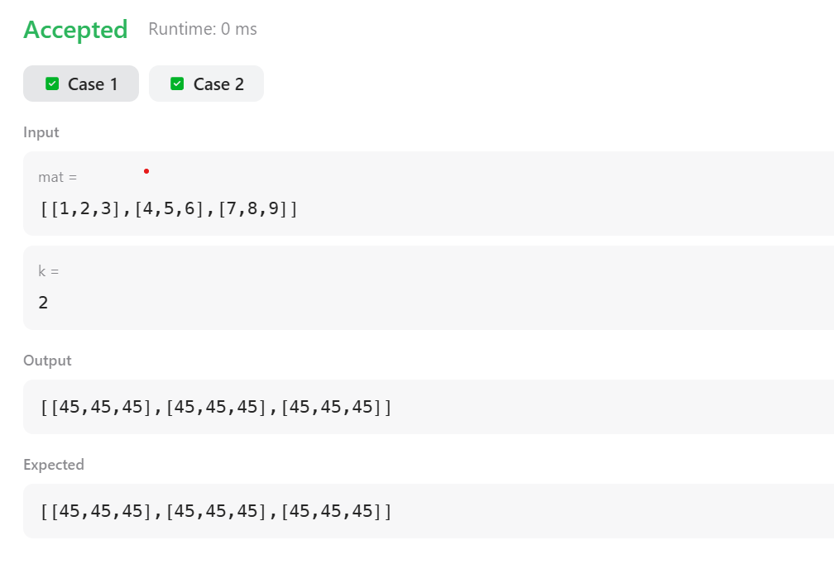

Result:
Thus the implementation of the matrix block sum was executed successfully and out put was verified successfully.

AIM:
To rotate a given square matrix by 90 degrees clockwise in place using an efficient algorithm without using extra space.

ALGORITHM :
Transpose the matrix
Convert rows into columns.
Swap matrix[i][j] with matrix[j][i] for all i < j.
Reverse each row
For every row, reverse the elements from left to right.
The matrix is now rotated 90° clockwise.
PROGRAM:
class Solution {
public void rotate(int[][] matrix) {
int n = matrix.length;
for (int i = 0; i < n; i++) {
for (int j = i + 1; j < n; j++) {
int temp = matrix[i][j];
matrix[i][j] = matrix[j][i];
matrix[j][i] = temp;
}
}
for (int i = 0; i < n; i++) {
int left = 0, right = n - 1;
while (left < right) {
int temp = matrix[i][left];
matrix[i][left] = matrix[i][right];
matrix[i][right] = temp;
left++;
right--;
}
}
}
}
OUTPUT:
1 2 3
4 5 6
7 8 9

7 4 1
8 5 2
9 6 3

Result:
Thus the implementation of the matrix rotation algorithm was executed successfully and out put was verified successfully

